Natural Language Processing:
Natural Language Processing (NLP) is a branch of artificial intelligence (AI) that focuses on enabling computers to understand, interpret, and generate human language in a way that is both meaningful and useful.

Components of NLP
There are the following two components of NLP -
- Natural Language Understanding (NLU)
- Natural Language Generation (NLG)
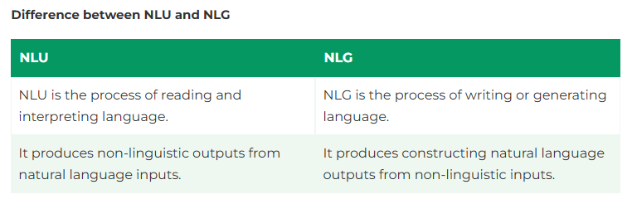
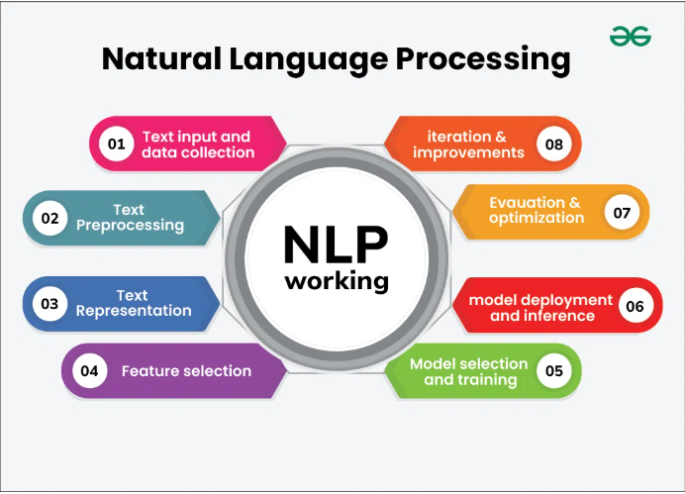
Steps involve in the NLP:
- Text processing :

- Sentence Segmentation: It breaks the paragraph into separate sentences.
- Tokenization: Splitting text into smaller units like words, sentences or phrases
- Lowercasing: Converting all text to lowercase to ensure uniformity.
- Stop word Removal: Removing common words that do not contribute significant meaning, such as “is” ,“and”, “the
- Punctuation Removal: Removing punctuation marks.
- Stemming and Lemmatization: Reducing words to their base or root forms. Stemming cuts off suffixes (Running to Run), while lemmatization considers the context and converts words to their meaningful base form(Better to Good)
- Text Normalization: Standardizing text format, including correcting spelling errors, expanding contractions, and handling special characters.
- Remove URL, numbers or special characters.

- Vectorization or Text Representation:
Vectorization techniques in Natural Language Processing (NLP) are essential for converting text data into numerical formats that machine learning algorithms can understand.

Primary vectorization techniques used in NLP as follows:
  - CountVectorizer (Bag of words) :
This tool creates a bag of words model where each unique word is represented by a number.

Example:
Imagine we have 3 sentences as follows:
1.”I love dogs.”
2.”I love cats.”
3.”Dogs and cats are cute.”

CountVectorizer does following steps:
1. Tokenization: Break down each sentence into individual words
Like this
[ “I”,”love”,”dogs.”]
[“I”,” love”,”cats.”]
[“Dogs”,”cats”,”are”,”cute.”]

2. Create a vocabulary: create a list of unique words found in sentences.
Like this
[ “I”, ”love”, ”dogs.”, ”cats.”, ”are”, ”cute.”]

3. Create a word frequencies and vector presentation: for each sentence count how many times each word from vocabulary appears. Where each number represent count of a word
Sentence1: [1, 1, 1, 0, 0, 0]
Sentence2: [1, 1, 0, 1, 0, 0]
Sentence3: [0, 0, 1, 1, 1, 1]

In summary, CountVectorizer simplifies many pre-processing tasks essential for converting text into a numerical format suitable for machine learning models. It handles tokenization, lowercasing, and stop word removal internally and also ignores punctuations, but does not include lemmatization or stemming by default.

from sklearn.feature_extraction.text import CountVectorizer

# Sample documents
documents = [
"I love programming.",
"I enjoy coding and programming."
]

# Initialize CountVectorizer with stop words removal
vectorizer = CountVectorizer(stop_words='english')

# Fit and transform documents into BoW vectors
X = vectorizer.fit_transform(documents)

# Convert to array for better visualization
bow_array = X.toarray()

# Display vocabulary and BoW vectors
print("Vocabulary:", vectorizer.get_feature_names_out())
print("Bag of Words Representation:\n", bow_array)

  - TF-IDF (Term frequency – Inverse document frequency):
Term Frequency measures how frequently a term appears in a document and IDF measures how important a term is across the entire corpus.
Here document is nothing but a single sentence (single observation) and corpus is nothing but all sentences in the dataset (total number of observations in dataset)

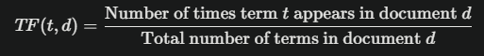

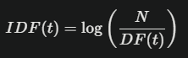

Where
N = total number of sentences or observations or documents in the dataset or corpus
DF (t) = total number of sentences in which the term t appear in the dataset or corpus

Example:
Sentence1:- “Hello, how are you doing, how is your campus, does everything good?”

Let’s calculate TF (How):
Number of time how appears = 2
Total number of terms in the sentence = 12

TF (How) = the number of times “How” appears in the sentence / total number of terms in the sentence

TF (How) = 2 / 12 = 0.166

Lets’ calculate IDF (How):
Let’s say there are total 100 observations in the dataset and out of 100 observations the term how is appear in 20 sentences

IDF (How) = ln(100 / 20) = 1.609

Now TF-IDF score of (how) = TF (How) * IDF(How)
= 0.166 * 1.609
= 0.268

Higher TF-IDF score represent more importance of that word in corpus
In summary, the TfidfVectorizer performs lowercasing and can remove stop words based on user configuration, while it handles punctuation during tokenization. However, stemming and lemmatization are not performed internally and must be applied as a separate pre-processing step before using the vectorizer.

# Import necessary libraries
from sklearn.feature_extraction.text import TfidfVectorizer

# Sample documents
documents = [
"I love programming.",
"Programming is fun.",
"I enjoy coding and programming.",
"Coding can be challenging."
]

# Initialize the TfidfVectorizer with stop words removal
vectorizer = TfidfVectorizer(stop_words='english')

# Fit and transform the documents into TF-IDF vectors
tfidf_matrix = vectorizer.fit_transform(documents)

# Convert the TF-IDF matrix to an array for better visualization
tfidf_array = tfidf_matrix.toarray()

# Get the feature names (i.e., words in the vocabulary)
feature_names = vectorizer.get_feature_names_out()

# Display the TF-IDF representation
print("TF-IDF Representation:")
for i, doc in enumerate(documents):
print(f"Document {i + 1}:")
for j in range(len(feature_names)):
if tfidf_array[i][j] > 0:
print(f" {feature_names[j]}: {tfidf_array[i][j]:.4f}")

# Optionally, display the complete TF-IDF matrix
print("\nComplete TF-IDF Matrix:")
print(tfidf_array)

  - Word Embedding’s:
The methods such as Bag of Words (BOW), CountVectorizer and TFIDF rely on the word count in a sentence but do not save any syntactical or semantic information
Word embedding’s are a crucial technique in Natural Language Processing (NLP) that represent words as numerical vectors.
This representation captures semantic and syntactic relationships between words, enabling models to understand context and meaning. Words that are similar in meaning or usage are positioned close to each other in this vector space.

Word2Vec: Developed by Google, Word2Vec uses neural networks to create word embedding’s. Word2Vec aims to capture the semantic relationships between words by mapping them to high-dimensional vectors. The underlying idea is that words with similar meanings should have similar vector representations.
There are two neural embedding methods for Word2Vec, Continuous Bag of Words (CBOW) and Skip-gram.

Continuous Bag of Words (CBOW):
It predicts a target word based on its surrounding context words. For example, given the context "the cat on the", it predicts "sat".

Skip-gram:
The main objective of Skip-Gram is to predict context words (words surrounding a target word) given a target word.

import nltk
from gensim.models import Word2Vec
from nltk.tokenize import word_tokenize

# Download the NLTK tokenizer models if not already downloaded
nltk.download('punkt')

# Sample text data (corpus)
corpus = [
"Word embeddings are dense vector representations of words.",
"They capture semantic relationships between words.",
"Word2Vec is a popular technique for generating word embeddings.",
"It uses context to learn representations."
]

# Tokenize the corpus into words
tokenized_corpus = [word_tokenize(sentence.lower()) for sentence in corpus]

# Train the Word2Vec model using Skip-Gram method (sg=1)
word2vec_model = Word2Vec(sentences=tokenized_corpus, vector_size=100, window=5, sg=1, min_count=1)

# Save the model for future use
word2vec_model.save("word2vec_model.model")

# Load the model (optional)
loaded_model = Word2Vec.load("word2vec_model.model")

# Example: Get vector representation for a specific word
word = "word"
vector_representation = loaded_model.wv[word]
print(f"Vector representation of '{word}':\n{vector_representation}")

# Example: Finding similar words
similar_words = loaded_model.wv.most_similar("word", topn=5)
print("\nMost similar words to 'word':")
for similar_word, similarity_score in similar_words:
print(f"{similar_word}: {similarity_score:.4f}")

Till now we have learn pre-process the data and convert the text input into numerical form by using various techniques such as Bag of words (CountVectorizer) / TF-IDF method / Word embedding’s method.
But how the NLP understand the data and produce the output
The five phases—lexical analysis, syntactic analysis, semantic analysis, discourse integration, and pragmatic analysis—work together to enable machines to understand and generate human language effectively.
- Lexical Analysis and Morphological:
The first phase of NLP is the Lexical Analysis. It divides the whole text into paragraphs, sentences, and words.
- Syntactic Analysis (Parsing):
Syntactic Analysis is used to check grammar, word arrangements, and shows the relationship among the words. Parsing involve assigns Parts-of-Speech (POS) tags (e.g., noun, verb) to each token. And Sentence Structure Analysis ensuring that the arrangement of words makes sense grammatically. For instance, "The cat sat on the mat" is syntactically correct, while "Sat cat mat the on" is not
- Semantic Analysis:
Semantic analysis is concerned with the meaning representation. It mainly focuses on the literal meaning of words, phrases, and sentences.
- Discourse Integration :
Discourse integration involves understanding how sentences relate to each other within a larger context. This includes recognizing how previous sentences influence the interpretation of subsequent ones.
- Pragmatic Analysis:
The final phase addresses how language is used in practice and its intended effects.

Applications of NLP:
- Question and Answering :
Question Answering focuses on building systems that automatically answer the questions asked by humans in a natural language.

- Spam Detection :
Spam detection is used to detect unwanted e-mails getting to a user's inbox.
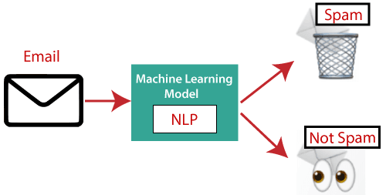

- Sentiment Analysis:
Sentiment Analysis is also known as opinion mining. It is used on the web to analyse the attitude, behaviour, and emotional state of the sender. This application is implemented through a combination of NLP (Natural Language Processing) and statistics by assigning the values to the text (positive, negative, or natural), identify the mood of the context (happy, sad, angry, etc.)
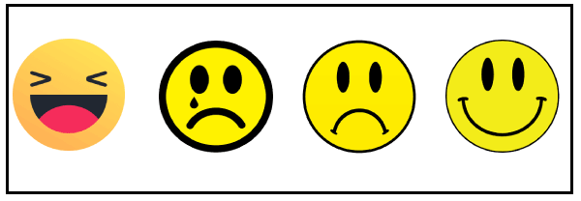
- Machine Translation:
Machine translation is used to translate text or speech from one natural language to another natural language.
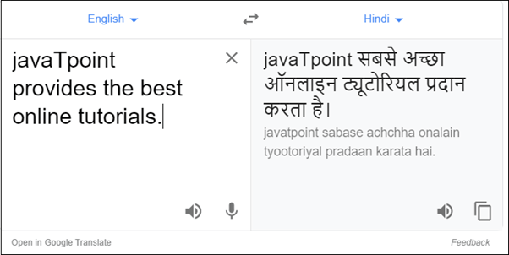
- Speech Recognition :
Speech recognition is used for converting spoken words into text. It is used in applications, such as mobile, home automation, video recovery, dictating to Microsoft Word, voice biometrics, voice user interface, and so on.

Challenges in NLP:
- Lexical Ambiguity: शब्दसंग्रहातील अस्पष्टता
[Same word different meaning]
Lexical ambiguity refers to the presence of multiple meanings within a single word. This can lead to confusion and misinterpretation, especially in natural language processing (NLP) where computers struggle to understand the intended meaning without sufficient context.
- Syntactic ambiguity: वाक्यरचनात्मक अस्पष्टता
Syntactic ambiguity, also known as structural ambiguity, occurs when a sentence can have multiple interpretations due to its grammatical structure.
I saw the man with the telescope."
This could mean:
  - I used the telescope to see the man.
  - I saw a man who had a telescope.
- Semantic Ambiguity:
Semantic ambiguity deals with the uncertainty of meaning within words, phrases, or sentences.

Semantic vs. Syntactic:
Syntactic ambiguity is about the grammatical structure of a sentence allowing multiple interpretations.
Semantic ambiguity is about the meaning of the words and their relationships, even when the structure is clear.

